Support our work – Community Woodland

Thank you very much for your interest in supporting the work of the Malvern Hills Trust.
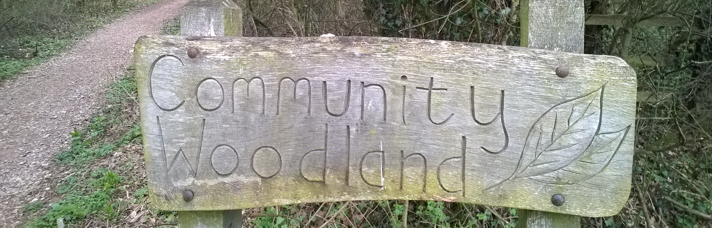
How can I help?
We’re looking for individuals, families and friends who may wish to support our work to improve access for visitors to the Community Woodland, Townsend Way.

The Community Woodland is a little known woodland along the eastern edge of Townsend Way, opposite Morrison’s supermarket and the Retail Park.

This young woodland is in close proximity to a large number of businesses, workplaces, and homes and we want to provide benches for visitors to relax and enjoy this open space.

Your donation will help us to create an attractive place within the woodland for quiet recreation for local residents and those employed nearby.

This is part of a larger access project within the Community Woodland that includes the purchase and installation of a footbridge and some path surfacing throughout the woodland to improve access for visitors.

As part of this project we will also be providing information for visitors to help them orientate themselves and find out more about this woodland habitat.

What will my donation be supporting?
We’ve got two types of benches that we’d like to provide for visitors.

Benches
The minimum donation for a bench is £450.
This includes:
- Purchase of bench
- Delivery
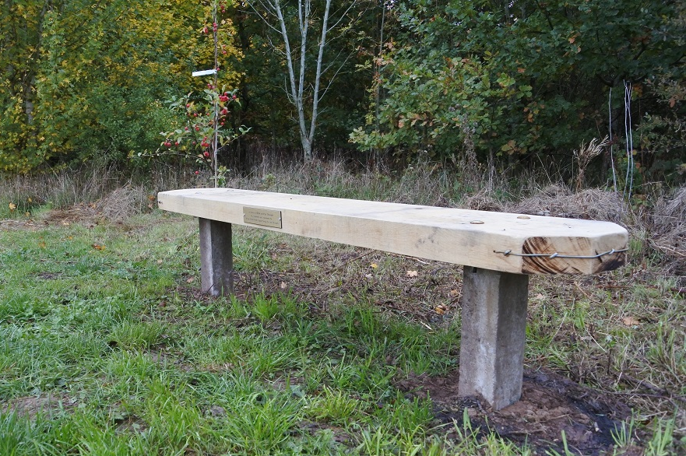
We will install the bench and maintain the bench for its life (estimated 20-25 years)

We want to provide 5 benches for visitors along the main path of the Community Woodland.

Please be aware that the benches are subject to availability. Should your application be received after the benches are all accounted for, we will be in touch to discuss alternative options.

We plan to install the benches in the autumn/winter of 2020 as part of a wider project to improve access to the Community Woodland.

Picnic benches
The minimum donation for a picnic bench is £1,500
This includes:
- Purchase of bench
- Delivery
We will install the bench and maintain the bench for its life (estimated 20-25 years)

We want to provide 2 picnic benches in the glade area of the Community Woodland for local residents and nearby workers who may want to escape the office at lunch.

Please be aware that the picnic benches are subject to availability. Should your application be received after the picnic benches are all accounted for, we will be in touch to discuss alternative options.

We plan to install the benches in the autumn/winter 2020 as part of a wider project to improve access to the Community Woodland.

How will my donation be recognised?
Benches – Plaques can be placed on the bench seat in memory or celebration. Plaques must be sourced externally by the donor. The maximum size for the plaque is: 12 to 24cm (length) x 5cm (height).

Picnic benches – Plaques can be places on the backs of the benches in memory or celebration. Plaques must be sourced externally by the donor. The maximum size for the plaque is: 12 to 24cm (length) x 5cm (height).

For all of the items, your name will also be recorded in our donations book which records all those who have kindly supported our work.

What do I need to do next?
If you wish to make a donation towards one of the above boards, please complete the application form below and email it to beck@malvernhills.org.uk or post to:
Malvern Hills Trust,
Manor House
Grange Road
Malvern
Worcestershire
WR14 3EY

We will then reply to your request with confirmation and more information. We will also get in touch should we need to discuss availability of contributions due to limited availability.

Who are we?
The Malvern Hills Trust owns, protects and manages the unique cultural heritage, wildlife and geology of his iconic English landscape for the benefit of the local community and the hundreds of thousands of visitors who come each year.

We have been caring for the Malvern Hills and surrounding commons since we were established in 1884 by an Act of Parliament, and are a registered charity.

Malvern Hills Trust is the working name of the Malvern Hills Conservators (charity number 515804).

For more information please contact the office on 01684 892002 or email info@malvernhills.org.uk

Donations for Community Woodland benches - Application form

Name:
Contact number:
Contact email:
Bench of choice* (please circle) | Bench | Picnic bench
Minimum donation amount | £450 | £1,500
*subject to availability.

Charity Gift Aid declaration

Boost your donation by 25p of Gift Aid for every £1 you donate

Gift Aid is reclaimed by the charity from the tax you pay for the current tax year. Your address is needed to identify you as a current tax payer. In order to Gift Aid your donation you must tick the box below.

I want to Gift Aid my donation of £______________ and any donations I make in the future or have made in the past 4 years to Malvern Hills Conservators.
I am a UK taxpayer and understand if I pay less Income tax and/or Capital gains tax than the amount of the Gift Aid claimed on all my donations in that tax year it is my responsibility to pay any difference.
My details
Title First name or initial(s)

Surname

Full home address

Postcode

Date

Signature

Please notify the charity if you:

- Want to cancel this declaration
- Change your name or home address
- No longer pay sufficient tax on your income and/or capital gains.

If you pay Income Tax at the higher or additional rate and want to receive the additional tax relief due to you, you must include all your Gift Aid donations on your Self-Assessment tax return or ask HM Revenue and Customs to adjust your tax code.

Data protection
The personal information provided on this form will be securely held and is subject to the provisions of the General Data Protection Regulations. The information is confidential and will not be passed on to any other person or organisation. For further information on Malvern Hills Trust’s privacy policy please see the website www.malvernhills.org.uk

