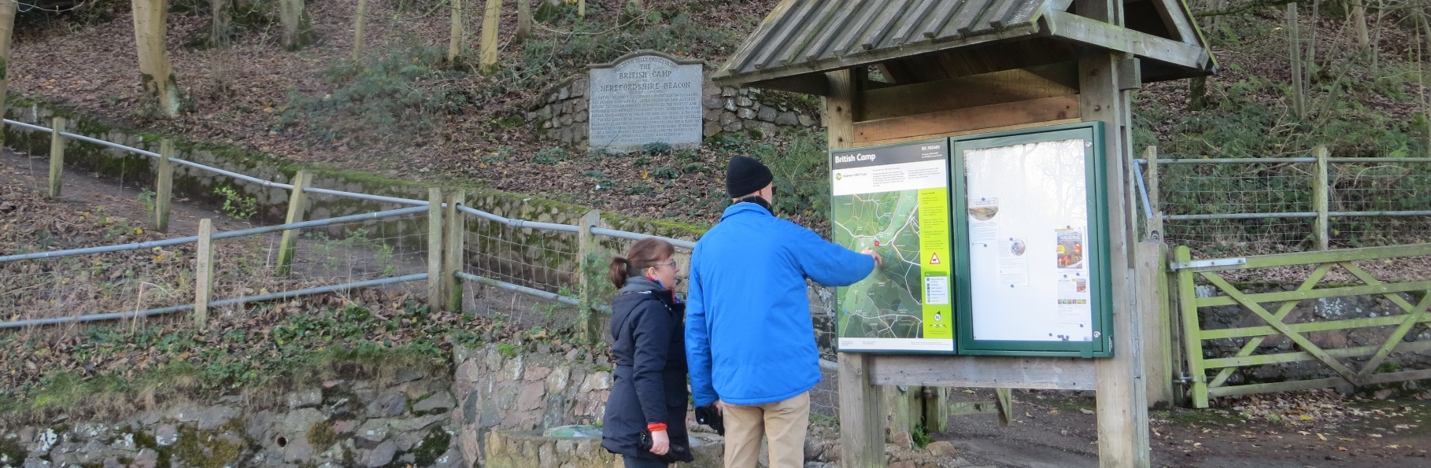
Support our work – Providing visitor information

Thank you very much for your interest in supporting the work of the Malvern Hills Trust.

How can I help?
We’re looking for individuals, families and friends who may wish to support our work to provide visitor information around the Malvern Hills and Commons.

The Malvern Hills and Commons are visited over 1 million times per year. Both the local community and visitors from far and wide come to take in the wide ranging views across the landscape. Others come to experience nature or the rich cultural heritage that can be found here.

We need to provide information boards for visitors to help them find out more about the local area and orientate themselves. We want to update all of our information boards as many of the existing boards are out of date, faded and do not reflect the amazing landscape we have here.

Your donation will help us to replace the information boards at Gardiner’s Quarry car park.

What will my donation be supporting?
The cost of a new information board is £4,000.

This cost includes:
- Writing of text and sourcing images
- Design and creation of visitor map
- Design and printing of the of the information board
- Design and building of frame
- Installation of the board
- Administration of the project
Donors have the option to either cover the full cost of replacing the information board, or to make a contribution of one or more ¼ shares (£1,000) of the cost.

You can see an example of one of the boards we’ve recently replaced at British Camp, Black Hill and Gardiner’s car parks.

We need to replace the information board at Gardiner’s Quarry car park
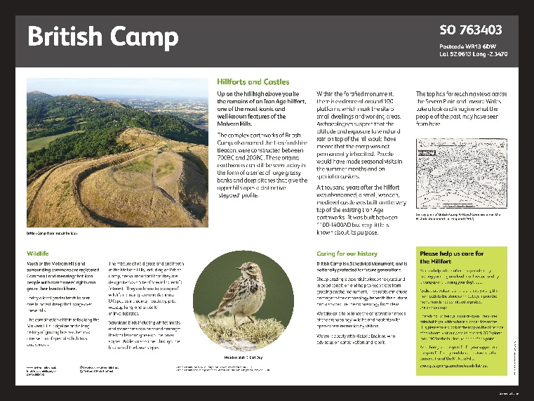
Earnslaw Quarry - The information here will focus on the Malvern’s quarrying history and the importance of these local businesses. It will also feature stories of some of the local people who have played a part in shaping this landscape.

Beacon Road - The information here will focus on the rare and important plant species found in the open habitats of the Malvern Hills. The tiny plants that survive in this harsh environment will be brought to life.

Please be aware that the boards are subject to availability. Should you application be received and the boards are already accounted for, we shall be in touch to discuss options.

Due to the COVID-19 outbreak we do not have a timescale for the installation of these boards and will restart the project on the situation has improved.

How will my donation be recognised?
In recognition of their donation, each donor will by acknowledged ‘With Thanks’ by name on bottom of the board itself. If you have a particular request for a dedication, please include this in the form below. Please note that space is limited and subject to availability.

Your name will also be recorded in our public donations book which records all those who have kindly supported our work.
What do I need to do next?
If you wish to make a donation towards one of the above boards, please complete the application form below and email it to beck@malvernhills.org.uk or post to:
Malvern Hills Trust,
Manor House
Grange Road
Malvern
Worcestershire
WR14 3EY

We will then reply to your request with confirmation and more information. We will also get in touch should we need to discuss availability of contributions due to limited availability.

Who are we?
The Malvern Hills Trust owns, protects and manages the unique cultural heritage, wildlife and geology of his iconic English landscape for the benefit of the local community and the hundreds of thousands of visitors who come each year.

We have been caring for the Malvern Hills and surrounding commons since we were established in 1884 by an Act of Parliament, and are a registered charity.

Malvern Hills Trust is the working name of the Malvern Hills Conservators (charity number 515804).

For more information please contact the office on 01684 892002 or email info@malvernhills.org.uk

Making a donation for information boards - Application form

Name:
Contact number:
Contact email:
Board of choice* (please circle) | Eanslaw Quarry information Board |  |  | Beacon Road information Board
Donation amount* (please circle) | 1 share  £1,000 | 2 shares  £2,000 | 3 shares  £3,000 |  | 4 shares (full amount)  £4,000
Name(s) to be included in recognition on information Board or ‘In Memory of…’
Please be aware that there is limited space for dedications.

*subject to availability.

Charity Gift Aid declaration

Boost your donation by 25p of Gift Aid for every £1 you donate

Gift Aid is reclaimed by the charity from the tax you pay for the current tax year. Your address is needed to identify you as a current tax payer. In order to Gift Aid your donation you must tick the box below.

I want to Gift Aid my donation of £______________ and any donations I make in the future or have made in the past 4 years to Malvern Hills Conservators.
I am a UK taxpayer and understand if I pay less Income tax and/or Capital gains tax than the amount of the Gift Aid claimed on all my donations in that tax year it is my responsibility to pay any difference.
My details
Title First name or initial(s)

Surname

Full home address

Postcode

Date

Signature

Please notify the charity if you:

- Want to cancel this declaration
- Change your name or home address
- No longer pay sufficient tax on your income and/or capital gains.

If you pay Income Tax at the higher or additional rate and want to receive the additional tax relief due to you, you must include all your Gift Aid donations on your Self-Assessment tax return or ask HM Revenue and Customs to adjust your tax code.

Data protection
The personal information provided on this form will be securely held and is subject to the provisions of the General Data Protection Regulations. The information is confidential and will not be passed on to any other person or organisation. For further information on Malvern Hills Trust’s privacy policy please see the website www.malvernhills.org.uk

