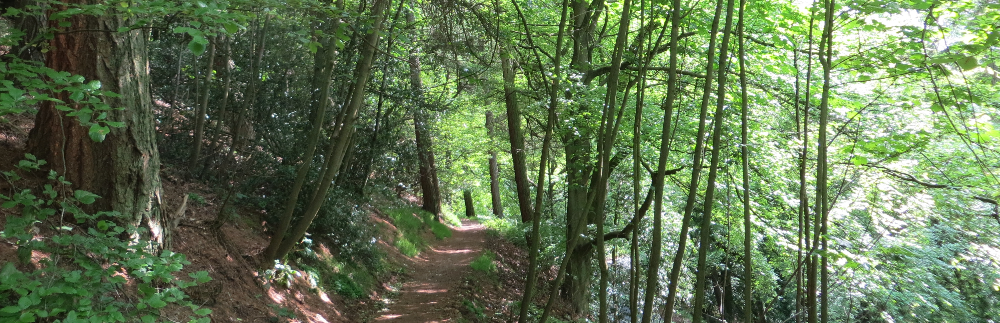
Support our work – Thirds Wood tree planting

Thank you very much for your interest in supporting the work of the Malvern Hills Trust.

How can I help?
We’re looking for individuals, families and friends who may wish to support our project to secure the future of Thirds Wood.

Thirds Wood was first planted around 1860 as a commemorative planting for Queen Vitoria’s Golden Jubilee. Straddling Jubilee Drive on the western side of the Hills, this woodland has a special character all of its own, earning it the local name of ‘Little Switzerland’.

In recent years we have undertaken woodland management in Thirds Wood which has included removing the diseased and weak trees to allow the healthier trees to mature. We now need to plant some saplings in the woodland that will be the next generation of trees.

Your donation will help us to plant new young trees in the wood to ensure that this scenic woodland and wildlife rich habitat is safe for the future.

What will my donation be supporting?
A donation of £20.00 will allow us to plant one sapling in Thirds Wood.

Your donation will cover the:
- Purchase of a sapling
- Transportation and delivery of saplings
- Planting and future management of the trees.
We are offering donors that opportunity to support us by making a donation of as many trees as they wish to secure the future of this woodland.

All of the trees will be native English species, sourced from a local tree nursery.
We plan to plant the trees in the winter of 2018/19.

How will my donation be recognised?
In recognition of your donation, your name will also be recorded in our public donations book which records all those who have kindly supported our work.

Unfortunately, due to the natural landscape of this woodland and the surrounding Hills we are unable to provide opportunities for plaques.

We will however be recognising those who have made a contribution to the future of Thirds Wood on our newly installed information board at Gardiner’s Quarry car park. Please note that this will be a general acknowledgement, not recognition for specific individuals.
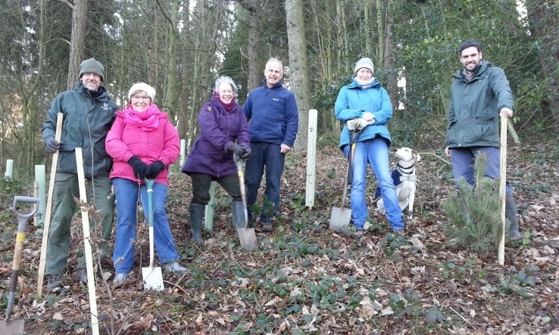
What do I need to do next?
If you wish to make a donation towards the future of Thirds Wood, please complete the application form below and email it to beck@malvernhills.org.uk or post to:
Malvern Hills Trust,
Manor House
Grange Road
Malver
Worcestershire
WR14 3EY

We will then reply to your request with confirmation and more information. We will also get in touch should we need to discuss availability of trees due to demand.

Who are we?
The Malvern Hills Trust owns, protects and manages the unique cultural heritage, wildlife and geology of his iconic English landscape for the benefit of the local community and the hundreds of thousands of visitors who come each year.

We have been caring for the Malvern Hills and surrounding commons since we were established in 1884 by an Act of Parliament, and are a registered charity.

Malvern Hills Trust is the working name of the Malvern Hills Conservators (charity number 515804).

For more information please contact the office on 01684 892002 or email info@malvernhills.org.uk

Making a donation for new trees - Application form

Name:
Contact number:
Contact email:
Number of trees
(Please specify)
Total donation
(Minimum donation £20.00 = 1 sapling)

Charity Gift Aid declaration

Boost your donation by 25p of Gift Aid for every £1 you donate

Gift Aid is reclaimed by the charity from the tax you pay for the current tax year. Your address is needed to identify you as a current tax payer. In order to Gift Aid your donation you must tick the box below.

I want to Gift Aid my donation of £______________ and any donations I make in the future or have made in the past 4 years to Malvern Hills Conservators.
I am a UK taxpayer and understand if I pay less Income tax and/or Capital gains tax than the amount of the Gift Aid claimed on all my donations in that tax year it is my responsibility to pay any difference.
My details
Title First name or initial(s)

Surname

Full home address

Postcode

Date

Signature

Please notify the charity if you:

- Want to cancel this declaration
- Change your name or home address
- No longer pay sufficient tax on your income and/or capital gains.

If you pay Income Tax at the higher or additional rate and want to receive the additional tax relief due to you, you must include all your Gift Aid donations on your Self-Assessment tax return or ask HM Revenue and Customs to adjust your tax code.

Data protection
The personal information provided on this form will be securely held and is subject to the provisions of the General Data Protection Regulations. The information is confidential and will not be passed on to any other person or organisation. For further information on Malvern Hills Trust’s privacy policy please see the website www.malvernhills.org.uk

